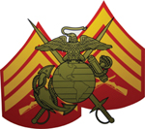

Monthly Newsletter
Corporal Johnny A. Williamson Detachment #1165

Marine Corps League - Asheboro, N.C.
October 2017 – December 2017
Our Next MCL Meeting Date: Tuesday October 17th

Detachment Officers 2017-2018

Commandant--------------------------- Harvey L. Allred
Phone: 336-629-8132
Cell: 336-460-0421
e-mail: hallred56@triad.rr.com
Senior Vice Commandant ------------ Danny R. Wood
Phone: 336-672-2865
Cell: 336-301-2299
e-mail: dwood@dmp-inc.com
Jr. Vice Commandant--Charles Zimmerman (Chuck)
Phone: 336-431-8964
e-mail: chuckieboy90@yahoo.com
Judge Advocate --------------James F. Stephens (Pete)
Phone: 336-685-9898
e-mail: bpstephens64@bellsouth.net
Adjutant ---------------------------- William Petty (Bill)
Phone: 336-889-7817
Cell: 336-953-3537
e-mail : tag1195@yahoo.com
Paymaster ------------------------ D. Filmore York (Fil)
Phone: 336-622-2121
Cell: 336-212-0223
e-mail: fyork@triad.rr.com
Chaplain -----------------------James R. Williams (Ron)
Phone: 336-625-9898
Cell: 336-963-3965
e-mail: nchp611@aol.com

Sergeant at Arms ----------------- Gary Q. Caviness
Phone: 336-879-3132
e-mail: garyandphyllis@rtmc.net
Historian -------------------------------- H. Carlton Cheek
Phone: 336-629-1049
e-mail : onehoursherry@triad.rr.com
Photographer --------------------------------- Steve Sugg
Phone: 336-879-4017
e-mail: sasugg@rtmc.net
Past Commandant -------------------- Danny R. Wood
2016-2017 Phone: 336-672-2865
Cell: 336-301-2299
e-mail: dwood@dmp-inc.com

This is your Newsletter, If there is anything You
would like to add for next month let me know ASAP !!

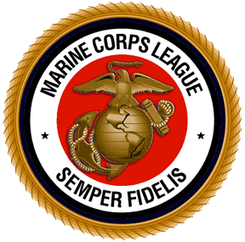
Upcoming Events
MCL Meeting : If You Come We Will Feed You! Between 1815 -1900 Dinner will be served at our monthly meetings. The Meal for October will be a Surprise Meal provided by Carl Corning. Come join us for the camaraderie with your fellow Marines. The meeting will begin around 1900 and conclude NLT 2000.

October 2017
Asheboro Fall Festival 7th - 8th
Blood Drive for Active Duty – Tuesday 10th
National Guard Armory, Asheboro 11 to 7pm
Detachment Meeting – Tuesday 17th
Social Hour / Dinner – 1800 Meeting 1900
American Legion Post 45, Lanier Avenue
November 2017
Flag Placement – Saturday 4th @
Oaklawn Cemetery – 0900 Until
Detachment Birthday Ball – Friday 10th Pinewood Country Club – 1800 Until
Veteran’s Day Parade – Saturday 11th
Ride on our MCL float line up at 1545
Downtown Asheboro – 1600 Parade Starts
Flag Retrieval – Sunday 12th @1300
Detachment Meeting – Tuesday 14th
Social Hour / Dinner – 1800 Meeting 1900
American Legion Post 45, Lanier Avenue
December 2017
5th Annual Christmas Party for the Kids 0900-1200
at the American Legion Hut on Saturday the 9th
Detachment Meeting – Tuesday 19th
Social Hour / Dinner – 1800 Meeting 1900
American Legion Post 45, Lanier Avenue

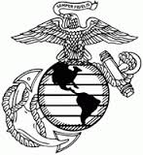

In Memory of

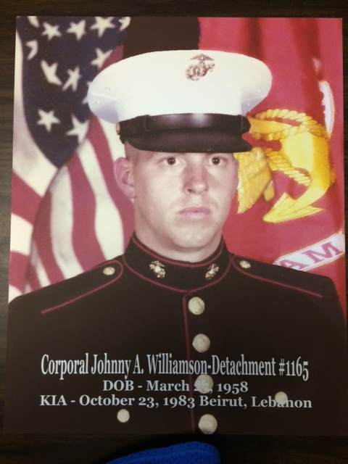

Corporal Johnny Adam Williamson was born March 27, 1958 and died, along with 219 fellow Marines in the Beirut barracks bombing in Beirut, Lebanon on October 23, 1983. His parents were Billy Glenn Williamson and Jewelene Dunlap Williamson. He also had a sister, Elizabeth Ann Williamson and a brother, Tony Glenn Williamson. Corporal Williamson was an acting Communications Chief in the United States Marine Corps. He attended North Moore High School and was a graduate of Randolph Technical College. He was a former employee of Union Carbide Corporation. He attended Amity Hills Baptist Church in Asheboro. Corporal Johnny Adam Williamson was laid to rest at Oaklawn Cemetery in Asheboro. Rest in Peace “ Marine “

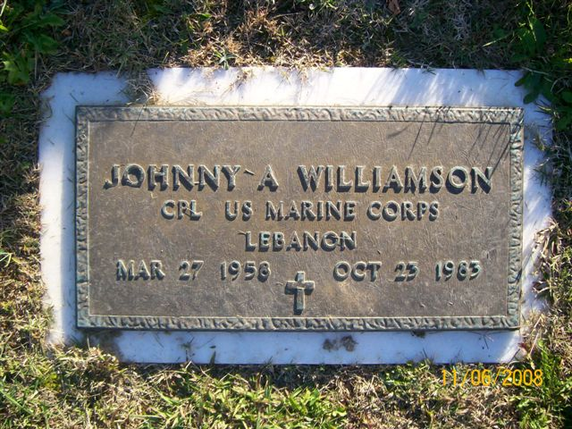

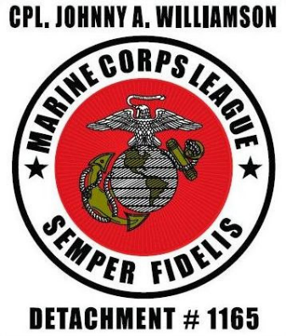
In Attendance at Our September 19th Meeting
Bill Beeson Harvey Allred
Bill Petty Ken Jalbert
Carlton Cheek Lucky Luckado
Carl Corning Mike Ingold
Chuck Zimmerman Mitchell Davis
Craig Wolfe Pete Stephens
Danny Wood Raymond Hoover Danny Wood Mike Ingold
Fil York Ron Williams
Gary Caviness Steve Sugg
Greg Callicutt Terrence Parson
Wally Waldridge
Associate Members Elizabeth Nault, & Zoe Faircloth
Our Evening Guest Melissa Jalbert

Congratulations This Month!!
Birthdays and Wedding Anniversary’s this Month
Greg Callicutt 1st Carl & Aimee Corning 5th
Russell Demedina 2nd Bill & Judy Beeson 18th
Bradley Tatham 6th Bradley & Tabitha Tatham 18th
Jerry Daniel 7th Roy & Allene Coltrane 19th
Bill Beeson 10th Tom & Nancy Kearns 31st
Richard Parks 10th
Clifford Harris 16th

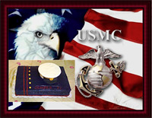

The Honoring Our Veterans Fund

Since its first event in September 2014, the Honoring Our Veterans organization has raised over $40,000 to assist needy veterans and support veteran causes in Randolph County. The Randolph County Veterans Council, which administers the funds, has used the funds to provide financial assistance to over 50 local veterans to date, covering a wide variety of needs such as medical bills, utility bills, rent, transportation to VA facilities and funeral expenses, among others.

The Honoring Our Veterans organization has also specifically authorized that a position of the funds be used to support the Randolph County Honor Guard (render military honors for deceased veterans) , to purchase flags to place on the graves of local veterans in support of Operation Remembrance and other veteran projects.

Honorably discharged Randolph County veterans who wish to apply for financial assistance from the Honoring Out Veterans fund may apply in person at the Randolph County Veterans Services Office, located at 158 Worth Street, Asheboro, N.C. 27203. Applicants must present a copy of his or her DD-214 discharge papers. For more information, please call 336-318-6909.

Veterans that do not have their discharge papers may contact the Register of Deeds office, which is co-located with the Veterans Services Office, to inquire about obtaining a copy of their DD-214. While there, they may also obtain a Veteran ID Card, which is valid for obtaining discounts from various local businesses. For More information, please call 336-318-6976

Planning Ahead for November 2017
Reminder: We will be asking for Nominations at our October 17th meeting for our Detachment Marine of the Year and also Woman of the Year.

Reminder: Annual Dues, All of our League Members Annual dues are due by November 10th. Annual dues are $30.00 a Year. Contact our Paymaster Filmore York for payment.
You can pay for you and a guest to attend the Birthday Ball $40.00 each and
Pay your annual dues in one payment if you would like. Total $110.00.

Your Invitation to Join Us
Marine Corps League
Birthday Ball

We Invite You and Your Guest to Join Us in Celebration of Our Corps 242nd Birthday Friday 10th November 2017

Pinewood Country Club
Cost: $40.00 Per Person
Members and Guest

Any Questions or Suggestions
Contact our Birthday Ball Committee
Harvey Allred 336-460-0421
Fil York 336-622-2121
Zoe Faircloth 336-625-2091

Make Check Payable to: Marine Corps League
*Cut off date to purchase Tickets
Monday November 6th*
Mail your payment to:
Paymaster Marine Corps League
P.O. Box 2431
Asheboro, N.C. 27204-2431
Phone: 336-212-0223
Thank You In Advance For Your Support ….



Come Celebrate our Corps 242nd Birthday

Evening Sequence of Events

1800-1900 “Happy Hour“
Socializing with Members and Guests
1900-2000 Everyone moves into the Dinning Room
for the evening Meal
Chaplain - Invocation
Dinner with Members and Guests
2000-2100 Birthday Ball Ceremony
Commandant - Welcome / Opening Remarks
All Rise - Presentation of Colors -

Davidson County Young Marines
Everyone Remains Standing - National Anthem
Reading of POW MIA
Cake Cutting Ceremony
Reading of the CMC Birthday Message
Commandant – Introduction of
Our Guest of Honor / Speaker CWO2 Marine Author /Journalist Tracy Crow
Detachment Commandants Closing Remarks
All Rise - Anchors Aweigh / The Marine's Hymn
2100-Until Music and Mingling

Dinner Menu
Salad Choices: Starches:
Fresh Fruit Mashed Potatoes
Salad Bar Wild Rice

Vegetable Choices: Entrée Choices:
Black-eyed Peas Carved Roast Beef
Green Beans Baked Chicken

Tea, Coffee, Water, Rolls & Butter included.
( Adult Beverages ) will be Sold in the Bar
Drink Responsibly!!

Thank You for Attending
Birthday Ball Committee

Our Birthday Ball Guest of Honor/Speaker
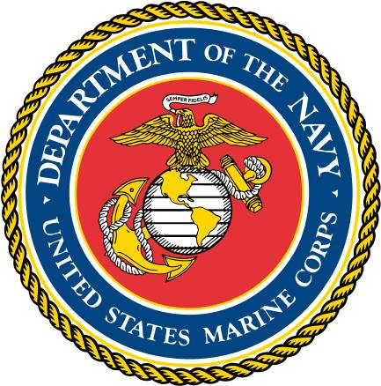
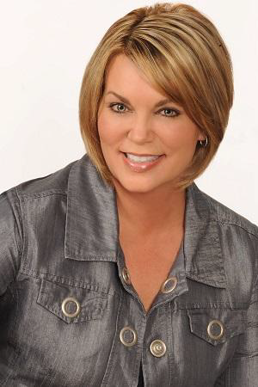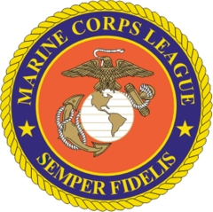
CWO2 Marine
Author /Journalist Tracy Crow

Tracy Crow, an award-winning military journalist, enlisted in the Marines in 1977 and served primarily in public affairs as a combat correspondent. She was a newly promoted staff sergeant in 1985 when selected for warrant officer, and after completing The Basic School at Quantico, was assigned as the public affairs officer for Marine Corps Air Station, New River, in Jacksonville, North Carolina. She left the Marines in 1987 as a chief warrant officer-2.
After the Marines, she completed her education, earning an M.F.A. from Queens University of Charlotte. As an assistant professor of journalism and creative writing, Tracy taught at the University of Tampa, St. Petersburg College, and Eckerd College in Florida.
Today, she is president and CEO of MilSpeak Foundation, a 501(c)3 public charitable organization that supports the creative arts endeavors of military servicemembers, veterans, and family members, and in this role she leads writing workshops and seminars throughout the country.
Tracy is the author of five books: the newly released popular history, It’s My Country Too: Women’s Military Stories from the American Revolution to Afghanistan; the award-winning, critically acclaimed military memoir, Eyes Right: Confessions from a Woman Marine; the novel, An Unlawful Order under her pen name Carver Greene; the breakthrough writing text, On Point: A Guide to Writing the Military Story; and the anthology, Red, White, and True: Stories from Veterans and Families, WWII to Present.
She is president of the North Carolina-3 Semper Fi Chapter of the Women Marines Association, and she and her husband Mark Weidemaier, a Major League Baseball lifer, live on ten acres in Liberty, North Carolina, with their dogs—Hadley, Cash, and Fenway.

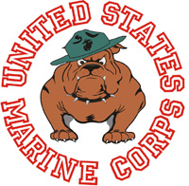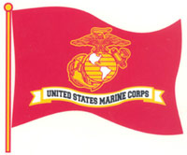
Upcoming Events
Your Invitation to Come Join Us in November

Flag Placement – Saturday 4th
Oaklawn Cemetery 0900 - Until

Our Marine Corps League Detachment Birthday Ball – Friday 10th
Pinewood Country Club 1800 – Until
Guest of Honor/Speaker Author /Journalist Tracy Crow

“Happy Birthday Marines Friday November 10th”

Veteran’s Day Parade - Saturday 11th
Downtown Asheboro Starts at 1600
Want to be in the Parade …. Be there to line up NLT 1545 on Church Street
For more information contact: Lucky Luckado 336-498-7146

Veteran’s Tribute Concert
Veteran’s Day Evening, Saturday November 11th right After the Parade
And Just Before the Pilot Club Luminary Display
Downtown Asheboro at the Old Court House
Honoring All Veteran’s and All Branches of the U.S. Armed Forces
For more information contact: Zoe Faircloth @ 336-625-2091
Military Appreciation at Golden Corral Free “ Thank You “ Dinner Monday November 13th, 2017 from 5pm to 9pm http://www.goldencorral.com/military/
Flag Retrieval OakLawn Cemetery – Sunday November 12th @ 1300

Detachment Meeting – Tuesday 21st
Social Hour 1800 / Dinner at 1815
Meeting 1900 to 2000
American Legion Post 45 Lanier Ave, Asheboro, N.C.

Corporal Johnny A. Williamson#1165 Our 5th Annual MCL Detachment Christmas Party for the Kids!

When? Saturday, December 9, 2017
0900 -1200 Noon
Where? American Legion Hut Post #45, Asheboro
All Randolph County Marines and children and grandchildren of Marines
Please bring a wrapped gift for each child you bring for Santa Clause to distribute
Candy and fruit bags will be given to all children by Santa
Coffee, soft drinks, chips and donuts will be provided by MCL Detachment #1165
Please advise number of children you will bring no later than December 5, 2017. Contact Ron Williams at 336-625-9898 or cell, 963-3965 or email nchpd611@aol.com

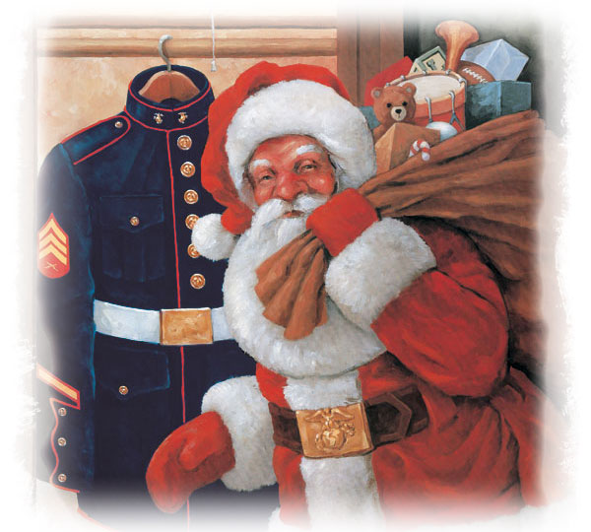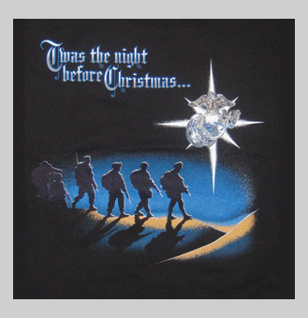

Toys for Tots Assistance: Contact Clay Andrews @ 336-465-1253 or firefighterc@triad.rr.com

Semper Fidelis

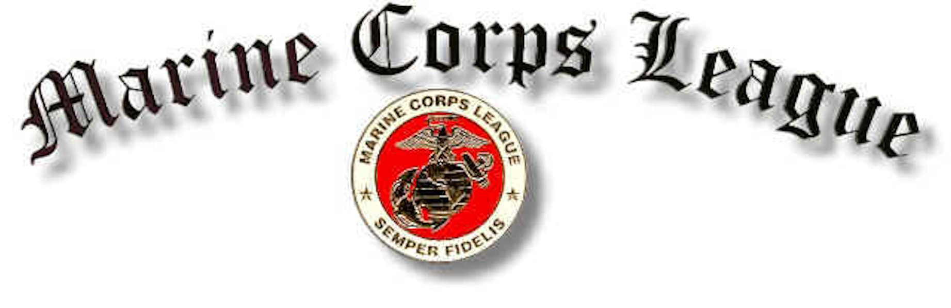
Corporal Johnny A. Williamson Detachment #1165

Marine Corps League Monthly Meeting Held September 19, 2017
At the American Legion Post 45 Asheboro, N.C.

There were a total of 24 in attendance 21 members, 2 associate members and 1 guest.

Commandant Harvey Allred called the meeting to order at 1900 hours.

Acting Sergeant at Arms Bill Beeson opened the meeting with everyone saying The Pledge of Allegiance while saluting our flag.

Chaplain Ron Williams gave the opening prayer.

Commandant Harvey Allred called for Sergeant at Arms to secure the quarters.

Harvey asked for everyone to remain standing for a moment of silence for our two members Bill Husband & William Schmidheini who had passed away

Sergeant at Arms declared the meeting open for official business.

Harvey asked for the roll call of officers present.

- Senior Vice Commandant – Danny Wood _ Present
- Junior Vice – Chuck Zimmerman _Present
- Judge Advocate – Pete Stephens -Present
- Adjutant – Bill Petty _ Present
- Paymaster – Filmore York _Present
- Chaplain – _Ron Williams_ Present
- Sgt-at-Arms – Gary Caviness _ Present

Introduction of Guests
Melissa Jalbert daughter of Ken Jalbert

Application for membership
None

Harvey Presented Greg Callicutt and Terrance Parson with their Marine Corps League pins and Steve Sugg with his life member pin.

Members or Family Members Sick or in Distress
Bill Beeson was acting Sgt at arms for Gary Caviness because Gary was suffering from kidney stones . Going to have surgery tomorrow on Wednesday.
Chuck Zimmerman said that he was going to the VA to get his head examined, because of headaches.

Report of Officers
I presented the quotes that I had received for a 10 x 10 canopy.
I passed the information around for everyone to review.

Harvey suggested that we should table this issue. We didn’t need to decide right now because we wouldn’t need one until our spring golf tournament in April.
Fil asked Ken Jalbert if he had received his pin and his metal lifetime card and Ken said that he had only received his paper lifetime card.
Fil said that he spoke with the new department paymaster and associate members can become lifetime members and Elizabeth Nault has paid her fees and she will be our newest lifetime member.
Harvey talked about the car show for the veterans that was held at Wayne Thomas Chevrolet on Saturday the 16th, and he said that there were around 220 plus cars and that they raised over $19000.00. Donations are still coming in.
Harvey said that he got a phone message while he was away about a Marine who needed some help that lived somewhere in either Coleridge or Erect area. He said he called the number and send e-mail, but hasn’t heard anything.
Harvey asked for volunteers to man the booth that we are going to share with AMVETS during the Fall Festival in Asheboro and he counted 7 hands.

New Business
Announcements for the good of the League

Harvey said that on Saturday November 4th at 9am we will place flags at Oaklawn cemetery. Flag retrieval will be Sunday November 12th at 1pm.

Harvey said that Ron Williams wanted to have the Christmas for the kids on Saturday December 9th from 9-12.
Greg Callicutt had a metal EGA that he bought and he said that he could get one if anybody wanted one for $25 and he told about the Marine Veteran NC license plate that he got from the DMV for only the cost of regular plate.
Mike Ingold said that his youngest son was going to be an aviation rescue swimmer for the Navy.
I shared an e-mail from Larry Beane telling about his 20 hour trip back to his new home in Florida after the hurricane, he said that he had no damage, and he said tell everybody hello and Semper Fi.
Fil said that all dues have been paid for this year.
Lucky said that he was getting 2 trucks from the Marines in Greensboro, and this year’s theme for the parade was Army and yet the National Guard had not offered anything

Harvey closed the meeting with the singing of the 1st verse of the Marine's Hymn.

Commandant asked Sergeant at Arms to lead us in the hand salute of our National Colors.

Chaplain Ron Williams gave the closing prayer.

Senior Vice Commandant Danny Wood preformed his last duty of the day.

Acting Sergeant at Arms Bill Beeson declared this meeting closed until our next meeting on October 17, 2017

50/50 winner was Ron Williams and he kept $5 and $46 to the league.

Respectfully submitted this day of October 17, 2017

Adjutant______________________________________________
Bill Petty

Accepted by Commandant________________________________
Harvey Allred

